Bonus points 2001 Field Day

100 points
100 % emergency power Deep cycle RV and Charging gas generator
100 points
Public location located on Rampart Range Road in Pikes National Forest.
100 points
Public information Table Colorado QRP Club
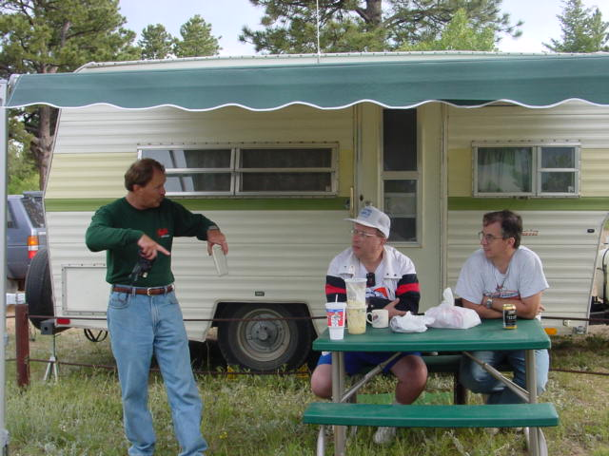
Paul KF7MD, Rich W0HEP Tin KR0U at the ready

100 points
Message Origination
To Rocky Mountain Division SM Tim Armagost WB0TUB
# 1 Routine from W0CQC sent to K0MF 0012 Z June 24 2001

100 points
Alternative Power Solar power
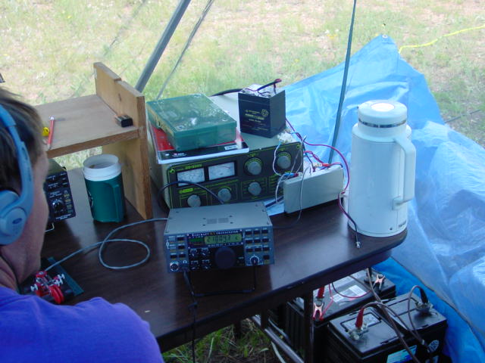
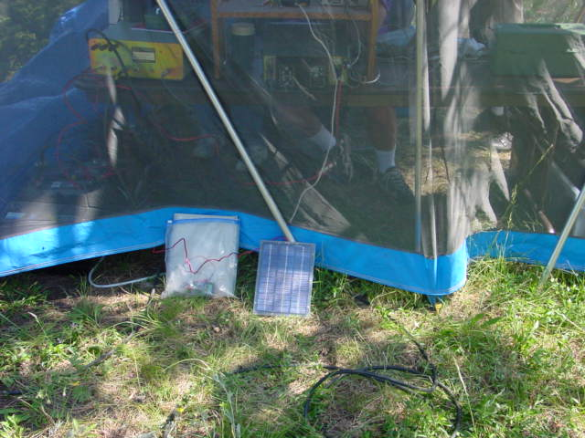
100 points
W1AW message enclosed
QST de W1AW
Spcl CW7 and cw26 follow
QST de W1AW hr spcl cw7 from ARRL hq Newington CT June 22, 2001
To all radio amateurs the first field day of the new millennium offers great opportunities to explore different aspects of our hobby. Is your club gaining the bonus points for up to 3 demonstration modes this year. APRS, portable packet, ATV and other modes may spur interest in new areas of the hobby.
Remember to use the newly designed field day summary sheets which are available from the ARRL contest web site in Adobe pdf format. Be sure to include dupe sheets by band. Full log files are not a requirement for the field day. Make sure that your entry includes copies of any message that you send or receive for bonus points. Stand by

QST de W1AW
We are always seeking interesting photographs that might be considered for use in the field day article in QST or on the ARRL web site.

Field day entries must be mailed to ARRL headquarters by July 24. Good luck and may your group have their best field day ever ar
GL de W1AW

100 points
Site visitation by Douglas County Deputy Sheriff Edgar, who stopped by,. He had just passed his Tech license and was on patrol and saw the 4 towers. Whow! We invited him back Saturday when he was off duty..
700 total points
Pictures from W0CQC 2001 Field Day site
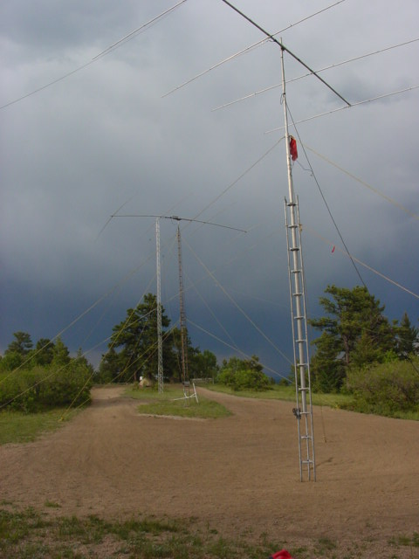
Front 4 el 15 m mid 4 el 20 m Far 60 ft with 80/40 m Dipoles
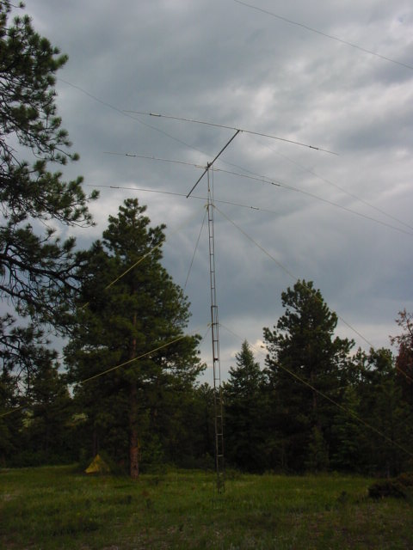
3 el Tribander SSB antenna 35 ft

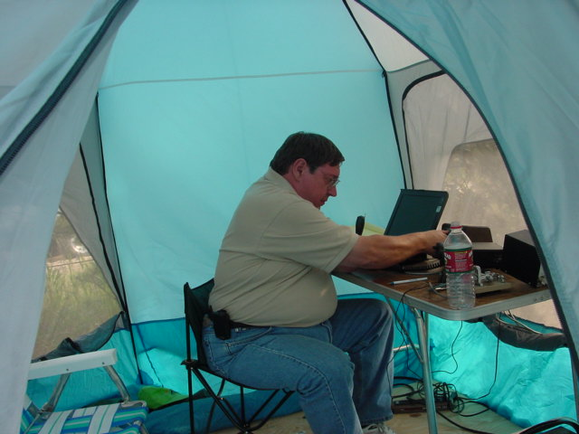
K0FEI VHF and UHF 207 q’s

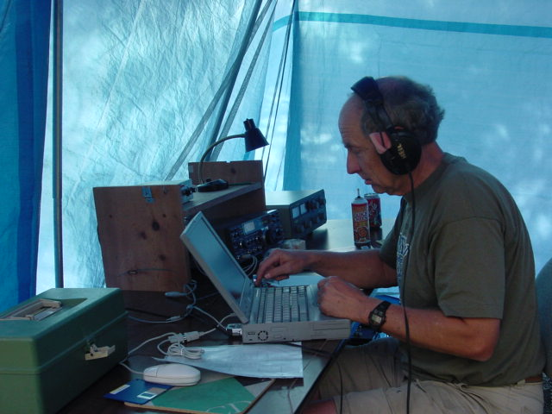
Doug W0AH on a hot run 15M CW, 774 Q’s on 40/15m

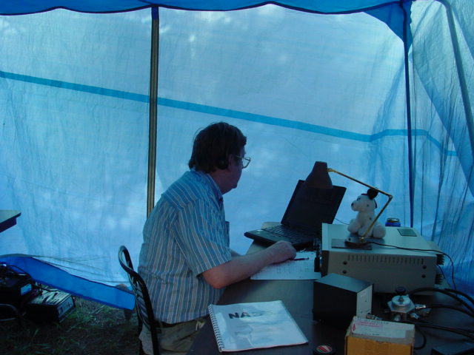
Marshall N1FN on 20/10/80 meter CW 789 Q’s on these bands
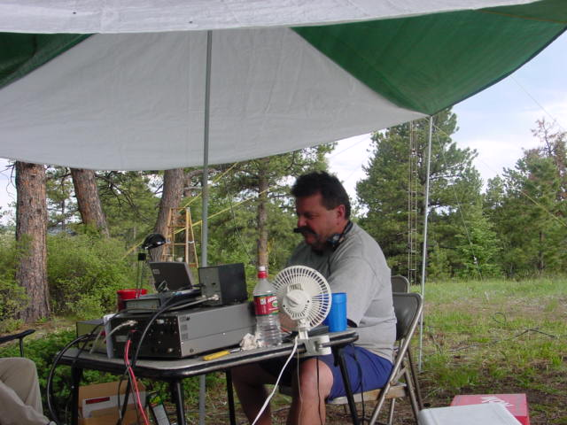
Al K0FRP, Hot weather, Man eating flies no screen tent, but the SSB station did 540 Q’s on SSB only 80-10m

2310 Q’s 20,410 points 1984 record was 18610
surpassed by 1800 points

